Request Prerequisite Override

Understanding Prerequisites, Concurrents, and Corequisites

PSU Policy C-5
Detailed explanations about Penn State’s policy on enforcement of prerequisite, concurrent or co-requisite courses can be found online.

Request Prerequisite Override Form: Requests to Add
- Submit a Request to Add if you are unable to add a class to your schedule due to missing an enforced pre-requisite or co-requisite.
- The cutoff time to submit an Add request is the date the session for the class begins, + 2 days. For example, if the class session begins August 21, an Add request can be submitted through August 23. This window allows for processing time during the session Drop/Add period.
- If the Add request is approved:
  - You will be notified via PSU email which sections are approved.
  - You can enroll through LionPATH for an approved section.
  - You can add yourself to a waitlist, set up swaps, and perform other enrollment activities for approved sections.
  - You are responsible for enrolling yourself.
- If the Add request is not approved, or if it was not approved for the desired section, you can submit a new request if you have additional information to provide.

Request Prerequisite Override Form: Requests to Drop
- Submit a Request to Drop when you want to drop a class that is an enforced concurrent or co-requisite for a class that you do want to stay enrolled in. For example, Chem 108 can only be taken when enrolled in Chem 110. In other words, Chem 110 is an enforced co-requisite for Chem 108. If you want to drop Chem 110 but stay enrolled in Chem 108, you need to submit a Prerequisite Override Request to drop Chem 110.
- The cutoff time to submit a Drop request is the late-drop deadline for the class.
  - If a request is submitted before the late-drop deadline, the class will be dropped upon approval.
- If the Drop request is approved and there are no Holds on your record preventing a drop:
  - The class will AUTOMATICALLY be dropped from your schedule.
    - If the request was submitted during the Drop/Add period, the class will be dropped from your schedule, but will not be on your record as a late-drop.
    - If the request was submitted after the Drop/Add period but before the late-drop deadline, the class will be dropped from your schedule and will be on your record as a late-drop.

Questions about Prerequisite Override Requests
Questions should be directed to your academic advisor or to the Office of the University Registrar by email registrar@psu.edu or by phone 814-865-6357.

Steps to Submit a Prerequisite Override Request
- Log into LionPATH using your Access ID and password.
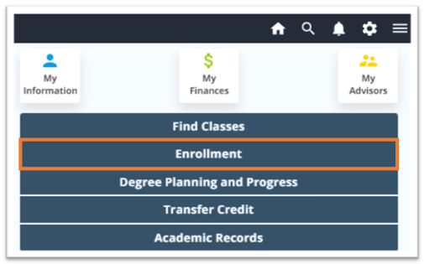
- From Student Home Base, click on the Enrollment button.

- Click Request Prerequisite Override from the left-hand menu.
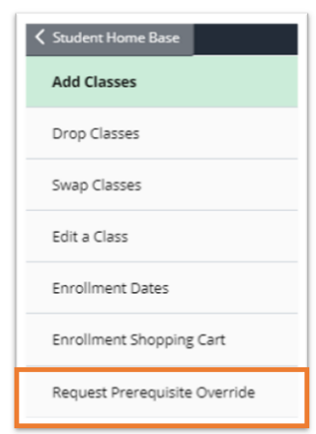
- Review the information presented on the page titled Prerequisite Override Request: Important.
- If proceeding with the request, click Next.
- Make the required selections on the page titled Prerequisite Override Request: Information.
- Select Add or Drop.
- Select Term.
TIP: If a choice is not included in the Add or Drop or the Term dropdown, it is likely due to the time of year. Discuss with your academic advisor if you should be able to submit your intended request.

- Click Next.
- You will be presented with different views based on whether the request is to Add or Drop.

When the request is to Add:
- Review the information presented on the page titled Prerequisite Override Request: Add a Class
- If you selected Summer on the previous screen, select a Campus.
- Select the Subject Area and Catalog Nbr. Only subjects and catalog numbers with enforced prerequisites will display in the dropdowns.
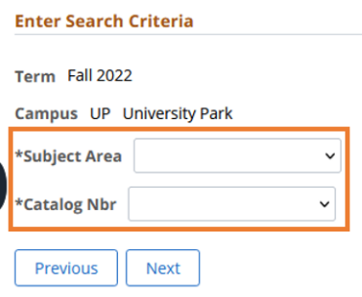

When the request is to Drop:
- Select (toggle to Yes) the course to drop. (You may only select one course per request.)
- Review the Acknowledge Drop Request and toggle to Yes if you wish to proceed.

- Click Next.
- On the page titled Prerequisite Override Request: Provide Justification:
- Type your responses into the required text boxes:
  - written justification (e.g., took prerequisite at another institution, prerequisite is not unavailable)
  - missing prerequisite/concurrent course(s).
- If applicable, in the File Attachments section, upload supporting documentation (e.g., transfer credit, email approval from instructor).
- When you are satisfied with your request, click Submit.
- Check your PSU email to confirm that your request was submitted. You will receive additional notifications via PSU email. Please expect 3-5 business days for your request to be processed.

TIP: If at any time you want to exit out of the request without submitting, click the Request Prerequisite Override link from the left-hand navigation. When presented with the Save Warning popup, click the No button to discard your changes.

Reminders
- If an Add request is approved:
  - You will be notified via PSU email which sections are approved.
  - You can enroll through LionPATH for an approved section.
  - You can add yourself to a waitlist, set up swaps, and perform other enrollment activities for approved sections.
  - You are responsible for enrolling yourself.
- If a Drop request is approved and there are no Holds on your record preventing a drop:
  - The class will AUTOMATICALLY be dropped from your schedule.
    - If the request was submitted during the Drop/Add period, the class will be dropped from your schedule, but will not be on your record as a late-drop.
    - If the request was submitted after the Drop/Add period but before the late-drop deadline, the class will be dropped from your schedule and will be on your record as a late-drop.

Questions should be directed to your academic advisor or to the Office of the University Registrar at registrar@psu.edu or 814-865-6357.

Statement of Non-Discrimination
The University is committed to equal access to programs, facilities, admission, and employment for all persons. It is the policy of the University to maintain an environment free of harassment and free of discrimination against any person because of age, race, color, ancestry, national origin, religion, creed, service in the uniformed services (as defined in state and federal law), veteran status, sex, sexual orientation, marital or family status, pregnancy, pregnancy-related conditions, physical or mental disability, gender, perceived gender, gender identity, genetic information or political ideas. Discriminatory conduct and harassment, as well as sexual misconduct and relationship violence, violates the dignity of individuals, impedes the realization of the University’s educational mission, and will not be tolerated. Direct all inquiries regarding the nondiscrimination policy to the Affirmative Action Office, The Pennsylvania State University, 328 Boucke Building, University Park, PA 16802-5901, Email: aao@psu.edu, Tel 814-863-0471.

