General Education Attribute Search in Class Search
You can search for classes with the General Education Attribute using Class Search.

Class Search: General Education Attribute
- Enter desired Term, Campus.
- In Course Career, enter Undergraduate.
- Expand the Additional Search Criteria by clicking the green arrow to the left of Additional Search Criteria.
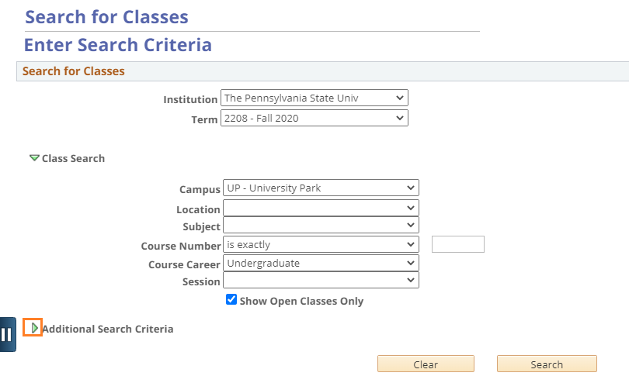
Figure 1: Additional Search Criteria
- Use the Course Attribute dropdown to select General Education.
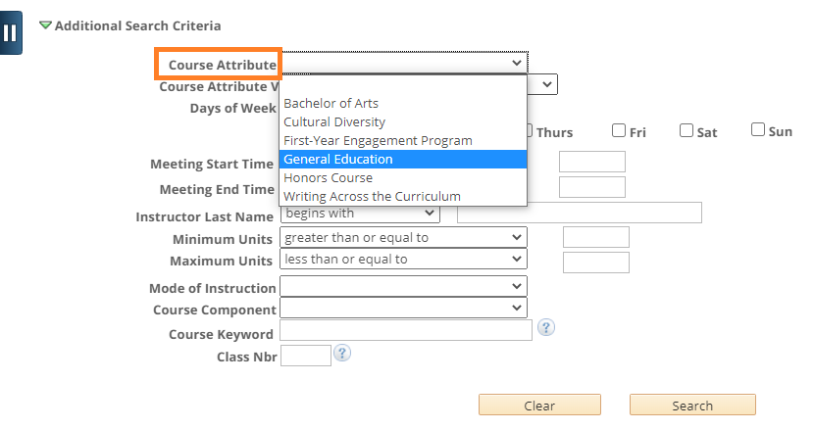
Figure 2: Course Attribute: General Education
- Use the Course Attribute Value dropdown to select the category of General Education you wish to search.

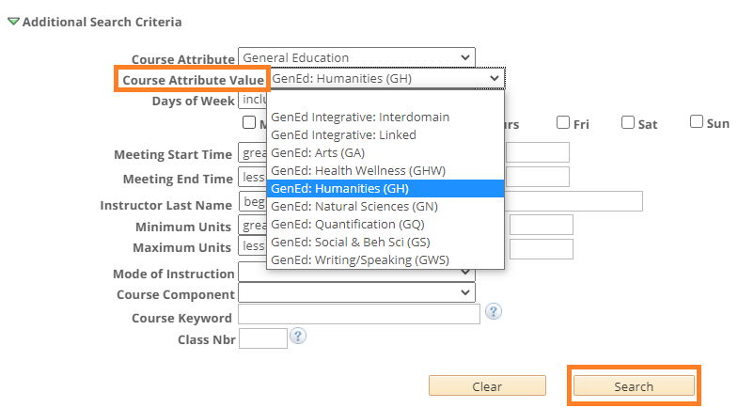
Figure 3: Course Attribute Value: GenEd Categories

Notes:
- To search for a specific Subject, enter the Subject in the Class Search section (Figure 1) and then proceed with using the Additional Search Criteria (Course Attribute dropdown and Course Attribute Values dropdown, if desired).
- There are other categories of courses that can be searched using the Course Attribute dropdown. Use these as needed to narrow your search results.

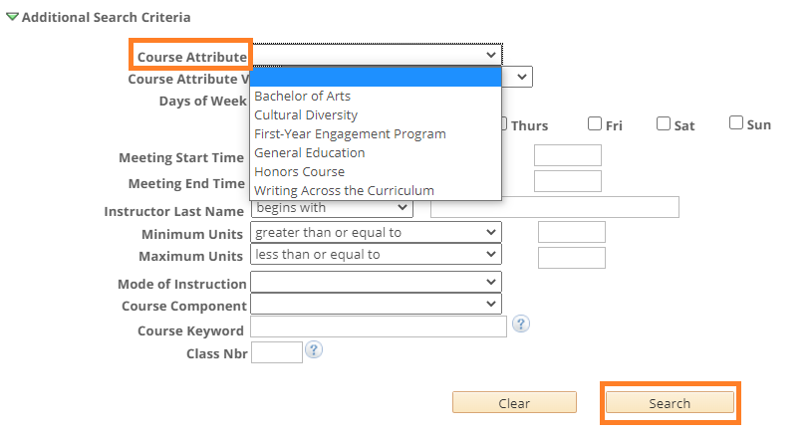
Figure 4: Course Attribute Dropdown

