Searching for Classes by Mode of Instruction
You can search for classes by Mode of Instruction using Class Search or Schedule Builder.

Class Search
- To display additional search options after entering Term and other Class Search criteria, expand the Additional Search Criteria by clicking the green arrow to the left of Additional Search Criteria.
- Use the Mode of Instruction dropdown to select a mode of instruction.
- Click the Search button.
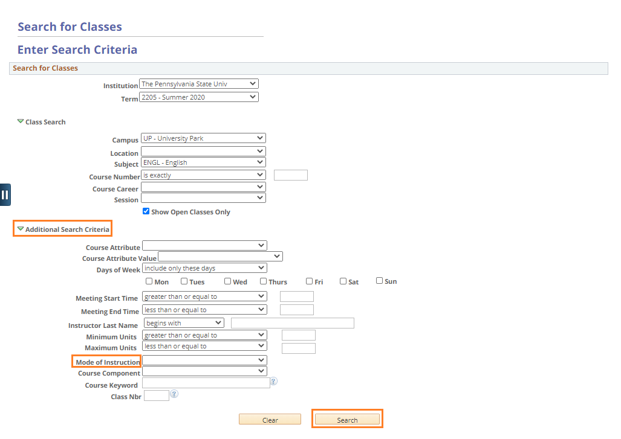
Figure 1: Class Search: Mode of Instruction

Schedule Builder
- Use the Change button to adjust Instruction Modes for your class search.
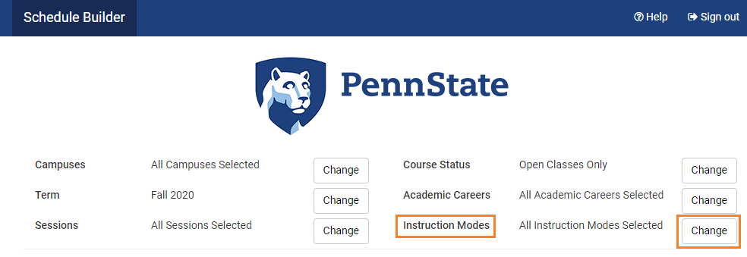
Figure 2: Schedule Builder: Instruction Modes

- Uncheck Select All Instruction Modes and select only those you wish search.
- Click Save.

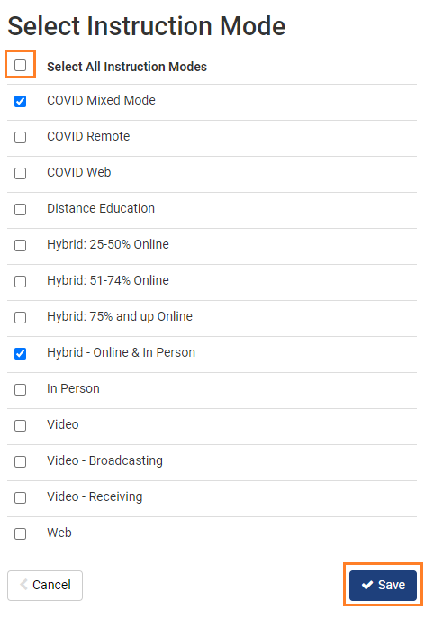
Figure 3: Schedule Builder: Select Instruction Mode

